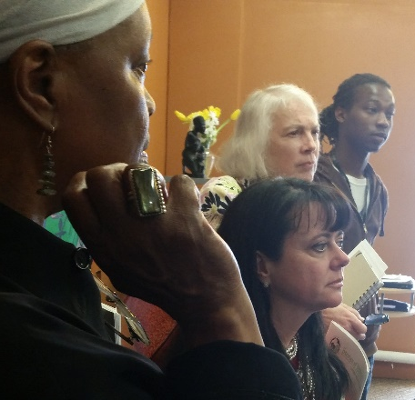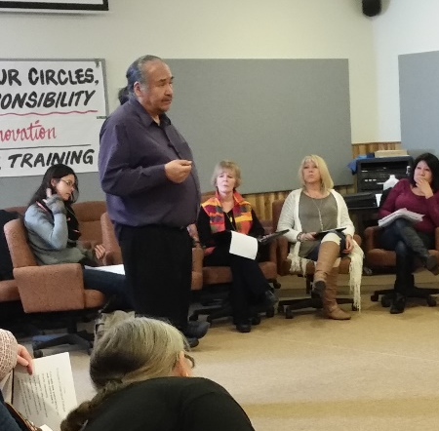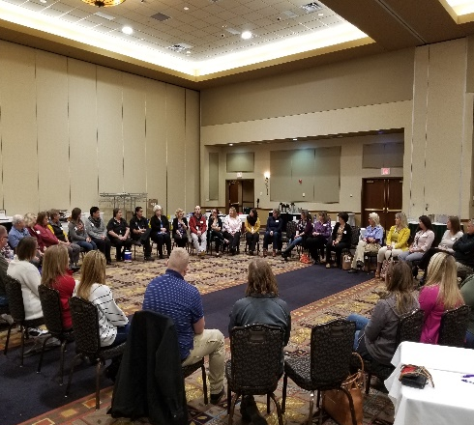

The Minneapolis Community Conversation Host Planning Team, Barbara Schneider Foundation and the Cultural Wellness Center Invite You and All Community Members to join us for a Minneapolis Community Conversation Cycle.
Nurturing a Positive & Unified Community
Minnesota Chippewa Tribe Building
1308 East Franklin Avenue
Minneapolis, Minnesota

May 9 Discovery Conversation
Noon: Lunch snacks served
1-5pm: The Best of Our Past and Present

May 23 Dream Conversation
8am: Breakfast snacks served
9am-1pm: Vision for our Community

June 6 Design Conversation
8am: Breakfast snacks served
9am-1pm: Putting form to Values & Vision

June 20 Delivery Conversation
Noon: Lunch snacks served
1-5pm: Forming Teams, Moving into Action

For Details Contact: Mark Anderson, 612 801 8572,
admin@thebarbaraschneiderfoundation.org

Building on the work of many organizations and individuals in our diverse Community, join us on this journey of asking powerful questions about our community’s strengths and assets that will unite us in unforeseen ways and bring into being the beauty of our dreams using the tool of conversation.

We have everything we need to nurture a positive and unified community and transform Minneapolis by making the possibilities we all envision a reality now. Transformation always begins with a conversation. Our diverse community can provide the vision needed to make our dreams a reality.

The way forward will emerge from the conversation.

